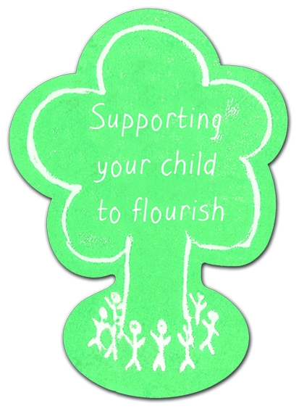
Request to Parenting Co-ordinator
(0-18 years)
Details of Person Completing Request
Date of Request: | Service Requested:  Group work can be considered? Yes ☐ No ☐
Name:
Designation: | Telephone Number:
Address: | Email Address:

“All staff involved in your child’s care have a duty of confidentiality governed by the Data Protection Act 1998 and the Human Rights Act 1998.” All of the details you provide will be kept safe and secure on NHS systems in accordance with the Data Protection Act 1998. Your information will only be accessed by those staff operating parenting services.

Details of Family
Child details
First name: | Surname: | Middle name:
Date of birth (dd/mm/yy): | Gender: Female ☐ Male ☐
Does the child attend a preschool establishment: Yes ☐ No ☐
Does the child have any additional support needs: Yes ☐ No ☐
if yes please specify additional support needs:

Postcode of current residence:

Information on Caregivers (if request for group, provide details of caregiver(s) attending group
Caregiver 1 details Caregiver 2 details (if applicable)
Surname:  First name:  Date of birth (dd/mm/yy):  Gender: Female ☐ Male ☐ Prefer not to say ☐  Address (Including postcode):  Telephone Number:  Email Address:  Preferred method of contact: Email ☐ Post ☐  Relationship to child:  Parent ☐ Foster Parent ☐Grandparent ☐  Other family, please specify:  Other, please specify:  Caregiver may be contacted via written correspondence, Please indicate any difficulties with literacy: | Surname:  First name:  Date of birth (dd/mm/yy):  Gender: Female ☐ Male ☐ Prefer not to say ☐  Address (Including postcode):  Telephone Number:  Email Address:  Preferred method of contact: Email ☐Post ☐  Relationship to child:  Parent ☐ Foster Parent ☐Grandparent ☐  Other family, please specify:  Other, please specify:  Caregiver may be contacted via written correspondence, Please indicate any difficulties with literacy:
Other Family Details
What type of household situation does your child live in?
One Parent household ☐ Two Parent household ☐ Combined Parent/Grandparent household ☐Other, please specify -
Is Child: Looked after Yes ☐ No ☐ Looked after and accommodated Yes ☐ No ☐
Please give details of all children in the household:
Child’s Name | Male/Female | DOB/CHI | Name of child’s school/ELCC

Please give details of any other agencies involved with the parent/child(ren):
Agency | Name | Contact Details
Health Visitor/Named Person
School/Named Person
ELCC
Social Worker
GP
Other:

Is the parent in agreement of this request? YES ☐ NO ☐
Does the parent consent to Health Visitor/School being informed of the outcome of request YES ☐ NO ☐
Is the parent willing to be contacted at a later date for follow up evaluation purposes? YES ☐ NO ☐
Please confirm you have discussed referral with Named Person (Health Visitor / School) YES ☐

1. What would the Parent like support with?
2. Please indicate what outcome(s) you wish to achieve with reference to relevant wellbeing indicators.
Do you foresee any barriers to engagement? e.g. childcare, caregiver additional support needs, medical needs of parent(s)
Are there any considerations which lone workers might need to take into account? E.g. any risk factors involved in home visiting?
Please return completed request form via email: ggc.westdunbartonshireparenting@nhs.scot
Or postal address: Parenting, The Vale Centre for Health and Care, Main Street, Alexandria, G83 0UA
Telephone Number: 01389 828242

